To get the template to work properly a Clinical Coordinator authorized to edit shared templates must perform the following steps from the CPRS GUI.

A.RETRIEVING CPRS TEMPLATES from a Webpage:
1. Access the webpage where the template is located
2. Find the template to retrieve
3. Right-click template and click “SAVE TARGET AS”
4. Change “SAVE IN” to “DESKTOP”
6. Click SAVE
(example)
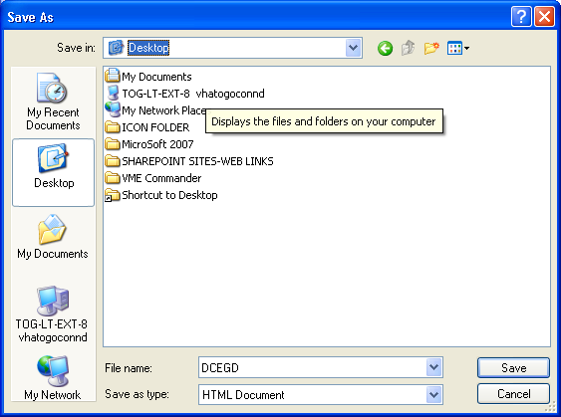

B. To import the Non-VA Request for Referral-FEE template:
1. Open CPRS
2. Select the Notes tab
3. Options... Edit Shared Templates (takes you to the Template editor)
4. Highlight the Shared Templates Folder
- Tools...Import Templates
6. From the Open dialog window...Look in: Desktop
7. Double click the document to import and the software does the rest.
8. Hit Apply button
9. Hit OK button to close TEMPLATE EDITOR

You can create a new folder w/in the SHARED TEMPLATES folder or place the template in the appropriate folder already in the Shared Templates.

C. To add the field “Reason for referral for Non-VA resources” to a locally created template:
1. Open CPRS
2. Select the Notes tab
3. Options... Edit Templates (takes you to the Template editor)
4. Highlight the My templates folder
- Tools...Import Templates
6. From the Open dialog window...Look in: Desktop
7. Double click the document to import and the software does the rest.
8. Hit Apply button
9. Open the template in Shared Template folder that should contain the field
10. Place cursor where the field should be located.
11. Type in: Reason for referral for Non-VA resource: and
12. Click on Edit…Insert template field…FEE REQUEST REFERRAL-REASON FOR
REFERRAL
13. Click on Insert Field
14. Hit Apply button
15. Hit OK button to close TEMPLATE EDITOR

Further information about setting up shared templates is available in the Computerized Patient Record System (CPRS) User Guide in the section on Creating Personal Document Templates.

